Enhancements to Dbox

Repacorp

Document Approval
Approver | Approved Date | Rejected Date | Comments
Rochelle Heinl

Part 1 Functionality Overview

Objectives (Why are we doing this?)

Repacorp wishes to roll the Dbox system out to their customers and in order to do so, some enhancements are required to make the experience a bit more streamlined for the customer.
Enhancement1: automatic entry of header information on transactional generation
- Currently when you are logged into Dbox as a customer you are limited to seeing your orders/information only, however the estimate and sales order transaction entry screen still forces you to select a customer after you hit the new estimate/sales order button.
- It is desired to (if logged in as a customer) to automatically populate the header of the estimate/sales order with the default information of the logged in customer when you hit the add estimate/sales order button.

Enhancement 2: leadtime/due date field hiding
- Repacorp customers can add a lot of different types of products to the transaction, therefore leadtimes can vary based on order makeup. Currently Repacorp does not communicate a leadtime/due date to the customer until the order has been reviewed and current reports do not show a leadtime/due date. It is desired to have a security preference to hide the due date/leadtime of the order from the Dbox transaction header and details for customers.
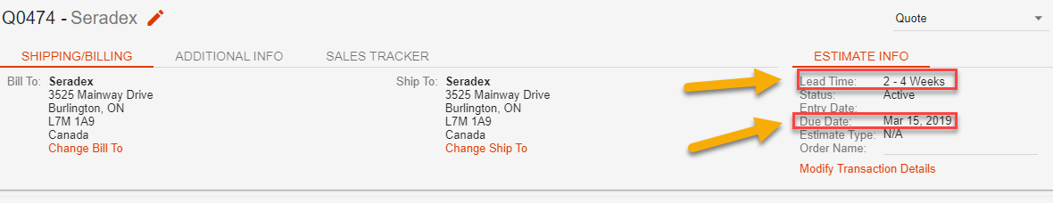

Enhancement 3 – Hyperlink addition to main menu
- Repacorp has a third party website used for pricing lookup. Repacorp would like to be able to add a hyperlink to the menu (any level) that will allow the user to click on and take them to the third party website.
- 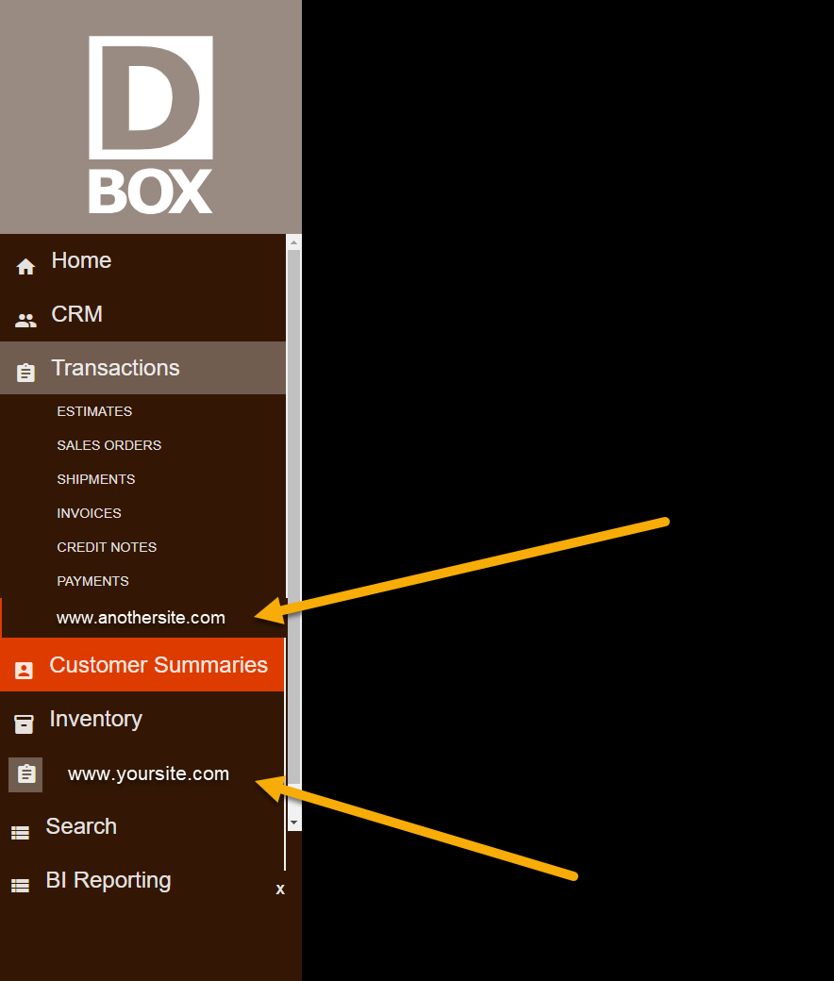
Enhancement 4 – artwork approval comments
In the current approval section for estimate/sales orders there is a revise button, but it is required to have a “approved” button to indicate final approval has been made. This would add an entry to the audit trail as well. Additionally, during the back and forth approval process, notes need to be added to the attachment to communicate changes/additions/deletions these additions of notes should also create audit trail entries.
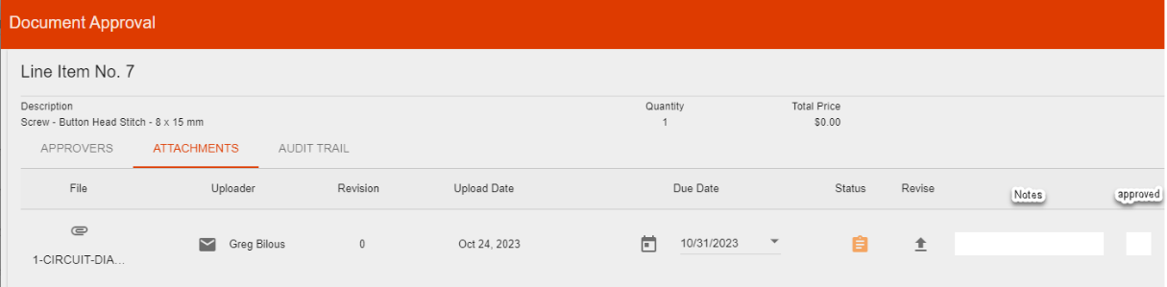

Part III – Change Order Details

Date | Enhancement | Requested By | Notes | Priority | Release Status

